Shabbos Stories for
Yom Tov Pesach 5776
Volume 7, Issue 34 15-23 Nissan 5776/ April 22-30, 2016
Printed L’illuy nishmas Nechama bas R’ Noach, a”h

For a free subscription, please forward your request to keren18@juno.com

The Fifth Question
By Yanki Tauber

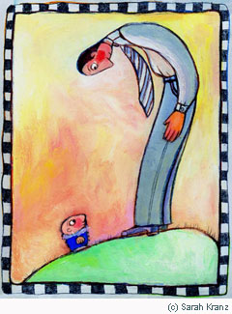

Mah nishtanah halailah hazeh..."Why is this night different from all other nights?" our children ask us at the Passover Seder. Because, we answer, we were slaves to Pharaoh in Egypt and G-d set us free.
Free? Are you free?
Can a person with a mortgage be free? Can a person with a mother-in-law be free? Can a person with a job be free? Can a person without a job be free?
Freedom! Is there anything more desired yet more elusive? Is there a need more basic to our souls, yet so beyond our reach? How, indeed, do we achieve freedom from the demands, cares and burdens of daily living?
But look at your child. Observe her at play, immersed in a book, asleep and smiling at her dreams. Assured that father and mother will feed him, protect him and worry about all that needs worrying about, the child is free. Free to revel in her inner self, free to grow and develop, open to the joys and possibilities of life.
This is why Passover, the festival of freedom, is so much the festival of the child. For it is the child who evokes in us the realization that we, too, are children of G-d, and are thus inherently and eternally free. It is the child who opens our eyes to the ultimate significance of Passover: that in taking us out of Egypt to make us His chosen people, G-d has liberated us of all enslavement and subjugation for all time.
The child is the most important participant at the Passover Seder. The entire Seder is constructed around the goal to mystify the child, to stimulate his curiosity, to compel him to ask: Why is this night different from all other nights?
The child asks, and we answer. But there is another dialogue taking place -- a dialogue in which we ask, and the child explains.
Take a good look at your child this Passover. Pay her close attention -- enter her mind, view reality from her perspective. For how else might we taste freedom?

Reprinted from the Pesach or Passover section of the Chabad.Org website.

The Explosion in Non-Gebrokts Products for Pesach

In recent years, non-gebrokts food has become a major trend. “People are noticing that matzah meal, a long-standing Pesach baking staple, is appearing less and less in packaged kosher-for-Pesach products,” observes Rabbi Nachum Rabinowitz, OU senior rabbinic coordinator.
The OU, which certifies more than 600,000 products produced in 6,000 plants in over eighty countries, is also one of the largest certifiers of Pesach products—both gebrokts and non-gebrokts.
Walk into the Pesach section of any supermarket and you will find the OU certification symbol on a dazzling selection of non-gebrokts delectable jelly rolls, cookies and cakes.
“Many of the Pesach brands that used to prepare matzah-meal based cakes are no longer doing so,” says Rabbi Rabinowitz. “Companies are replacing matzah meal with potato or tapioca starch.” As the Chassidic population grows (a much-cited 2011 UJA-Federation study revealed that Chassidim are the largest Orthodox group in the greater New York area), so does the number of non-gebrokts eaters. Yet religion isn’t the only cause behind the explosion in non-gebrokts products. Non-gebrokts cuisine is wheat-free; thus, the custom dovetails with another major food trend—the shift toward gluten-free eating. Gluten, the protein that gives breads their elasticity, has been implicated as the cause of celiac disease, a digestive disorder which can cause a range of unpleasant symptoms.
Relatively few people have true celiac disease, but a great many people have celiac-like symptoms. Upon the advice of natural-health practitioners or on their own advisement, many people have adopted the celiac diet, which consists namely of abstaining from foods containing gluten. That means that a lot of people are staying away from “gebrokts” all year round.
In fact, some celiac sufferers have been known to amass a supply of gluten-free food during the Pesach season to last the year. “More and more items are non-gebrokts, as suppliers want to cater to the gluten-free segment and non-gebrokts items have that crossover appeal,” says Yakov Yarmove, corporate business manager of ethnic marketing and specialty foods for the Supervalu supermarket chain, which has 1,800 stores in thirty-nine states.
Many Pesach hotels now advertise non-gebrokts cuisine as a way to attract the largest number of potential guests. “It also gives the impression that the hotel is taking care of every kosher detail, such as glatt kosher, pas Yisrael, et cetera,” notes Rabbi Eli Gersten, OU rabbinic coordinator and recorder of OU policy.
Not everybody is happy with the change, however. Jewish cyber message boards abound with complaints from disgruntled hotel guests upset that they had to endure the Sedarim without matzah ball soup. Even for those who don’t “mish,” Yiddish slang referring to the practice of eating only home-made food on Pesach, non-gebrokts home cuisine has also evolved. Cookbook author Tamar Ansh has penned two best sellers containing more than 300 non-gebrokts recipes, such as ersatz knaidlach made from ground chicken.

Reprinted from the Parshas Shemini 5776 email of Torah Teaser

A Strange Seder
By Gershon Kranzler
Published and copyrighted by Kehot Publication Society

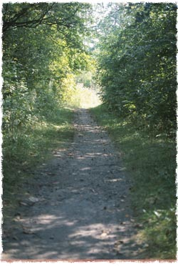

It was shortly before Passover. The court of Rabbi Baruch was quickly filling with his faithful disciples and admirers who came from afar to spend the holiday of Passover with their beloved Rebbe.
Rabbi Baruch himself was restless. The house was perfectly ready. He himself had spent weeks not only clearing away the outer chametz, leaven, in every nook and cranny of the home, but searching within himself too for the "leaven" of possible sin or wrongdoing in his soul.
But something else was amiss, he could feel it, though he was cheered by the arrival of his good friends and followers.
There was hardly a minute when he did not have to greet one or another of his chasidim who had come from afar, leaving their families behind to be with him at the seder. For the seder nights were a thrilling experience of learning for Rabbi Baruch's followers.
Suddenly, only two nights before Passover, the call came to him to leave the security and peace of his home and go forth on a mission.

Somewhere…He Had
Something to Accomplish
Somewhere, near or far, he had something to accomplish. And there was no stopping Rabbi Baruch. His family and chassidim knew that there was no use in trying to argue with him. The next morning Rabbi Baruch rose early and packed wine, matzot and other necessities for the seder.
He set out on a journey into the unknown while his stunned and disappointed chassidim sadly watched him depart.
Somehow, they hoped, and Rabbi Baruch hoped with them, that his mission would be a brief one that would allow him to return in time for the first seder.
But the day passed. The wind was strong, and snow kept piling up on the road as the coach covered mile after mile of slippery road. As they travelled eastward, the horse itself chose the way when they came to a crossroads.
When night fell, a house was nowhere in sight. The weather became unbearable; ice and snow lashed at horse and men. Rabbi Baruch, immersed in thought and prayer, did not feel a thing.

“We Cannot Go On…”
But finally the coachman turned to him and said, "I am afraid, Rebbe, we cannot go on. We'll have to stay here in the midst of the forest. The icy winds and snow are too strong, and my horse cannot hold out much longer. Let's try to spend the remainder of the night here."
Rabbi Baruch and the coachman bedded down in the wagon as best they could. They threw a heavy blanket over the horse and prepared to spend the night in this lonely spot, far from the comforts of Rabbi Baruch's court. The storm became increasingly strong.
The winds howled and the very earth seemed to shake and rumble under the onslaught of the elements. Suddenly, there was a terrifying roar in the distance. The ground shook, and the horse tore itself loose and ran away in terror.
"We must follow him and catch him, or else we shall have to spend the Yom Tovhere in this terrible wilderness!" The coachman shouted. He took the wagon, lamp and whip and Rabbi Baruch put the small bundles of seder provisions in his coat pockets, and they set out to find the horse.
The storm did not let up. Snow, ice and howling winds made their attempt to follow the horse ever more difficult, until they were ready to give up and turn back to the wagon. But that, too, now seemed impossible.
Suddenly, the coachman pointed in the direction in which the horse had run. A small light seemed visible from afar, shaking wildly to and fro. And then there was more wild rumbling underground, and the light was gone. To Rabbi Baruch it seemed as if he had heard human voices crying.

More Terrible than Any
Cries He Had Ever Heard
And even though it came from the far distance and was only a thin sound, it seemed more terrible than any cries he had ever heard.
"We must go there to see what happened," he said. Despite the protests of the coachman, who was frightened by the unusual events and worn out by the struggle against the elements, they pushed through the snow, step by step. Suddenly they heard the cry again, stronger than before and still terrifying.
"Faster, faster," urged Rabbi Baruch. "Someone over there needs our help."
After a long and painful struggle over every inch of the way, they finally came close enough to see that a whole piece of ground seemed broken off as if by a giant's hand and thrown into the depths. "There must have been a quake in the mines that end below the forest." This time even the coachman heard the voice, full of horror, that came from the depth.
"We must try to get down there, regardless of the risk."

In Vain the Coachman Tried
To Discourage Rabbi Baruch
In vain the coachman pointed out the impossibility of climbing down the steep, jagged edge. Sliding, rolling from rock to rock, clinging desperately to roots of trees that were broken off like matches, they scrambled down the incline.
What they saw made them shudder. The quake had crushed a small settlement of several houses that now lay on the ground all split apart, with walls, roofs and beams sticking out at crazy angles. Worst of all, from the midst of the rubble heap came the moaning and occasional wild cries that had brought them here.
Quickly now, disregarding all danger to themselves, they made their way down to the remnant of the settlement.
Ignoring the lifeless bodies of men, women and children beneath the walls, crumbled roofs and tree trunks, they directed all their efforts to helping those whom they found alive, pinned under heavy objects, dazed, blinded, or seriously wounded.
Their weariness seemed to have vanished, and they did not feel their own scratches and wounds as they went from person to person, wiping away blood and tearing their clothes into strips to stop the bleeding.
The coachman managed to make a fire. They melted snow for hot water, and their bottle of whiskey helped to dull the people's pain. They quickly realized that the place had been occupied by yishuvniks, Jewish settlers who lived here far from a town, at the edge of the forest.

The Survivors Thought the
Rabbi and Coachmen Were Angels
Those who were able to speak believed the rabbi and the coachman were angels sent to them by G-d in their hour of need.
"We are human beings like you, but it was surely the hand of the Almighty who led us here," Rabbi Baruch told them. He kept on speaking in his kind voice, calming the terrified people who were searching about for their loved ones.
Morning dawned by the time they had finished administering first aid. They had found twelve adults and several children still alive.
Slowly, laboriously, they took them all into the cellar of one of the houses that had miraculously remained almost intact, and bedded them down on whatever clothes, rags or covers they could find.
It was almost evening when it occurred to Rabbi Baruch and the coachman that this was the seder night. Trying to help the unfortunate victims of the catastrophe, they had not had time to think of anything else.

Hurriedly Set uyp the Most
Primitive Seder One Could Imagine
But now they hurriedly set up the most primitive seder one can imagine. Together everyone prayed with Rabbi Baruch, who said the evening prayers word for word so that the poor yishuvniks could follow him. Then the small packages of Passover provisions from the deep coat pockets of the Rabbi took their place on the table which had been set up on a large rock in the cellar.
The small, dim wagon lamp provided light. But the genuine brightness of that unforgettable seder flowed from Rabbi Baruch. Although he had not rested a minute during the past thirty six hours, he did not feel his weariness.
All night he went through the ritual of the seder, sharing the matzot, wine and vegetables with the people. He told them the beautiful stories of the Exodusfrom Egypt as they had never heard them before.
His stories, examples and inspiring thoughts made them forget all their pains, worries and loss. At dawn they all went to sleep as well as they could, in a more festive mood somehow than they had even known in happier times.
The day of Yom Tov and the second seder passed almost as peacefully, although the wounded began to get restless again, as if the daylight made them forget the magic of Rabbi Baruch's beautiful and inspiring stories and prayers.
Suddenly, they heard voices from a distance. The huddled group watched for several hours until finally a group of rescuers made the dangerous climb down the steep edge. As the coachman had suspected, in the wake of the storm an earthquake had dislodged some of the old coal mine walls on which the small settlement was built.

Rescuers Came from a Nearby Village
The rescuers had come from a nearby village after finding the terrified horse running wild. They had discovered the catastrophe, and brought everything necessary to help the survivors.
With the help of strong ropes attached to makeshift hoists, the rescuers lifted the wounded on stretchers. Wagons were waiting above to take them away. But, to the surprise of the rescuers, all said they would prefer to wait with Rabbi Baruch until the Yom Tov was over and then follow him to his town.
Only the seriously wounded, at Rabbi Baruch's request, agreed to be taken away at once.
Thus it was that on the first day of Chol Hamoed, the intermediate days of the holiday, a group of wagons pulled up in front of Rabbi Baruch's court. There the chassidim were waiting patiently, praying and enjoying the holiday quietly, hoping for the speedy return of their beloved Rebbe.
Although they knew that whenever Rabbi Baruch went on one of his missions it was because an urgent situation needed his personal attention, the story they heard from the survivors was even stranger than they had anticipated.
To all of the chassidim it seemed indeed a miracle that Rabbi Baruch had been nearby when the earthquake occurred and had noticed the light and the voices from afar.
The stories of the unusual seder nights in the cellar were a source of great satisfaction and a partial reward for their own disappointment at having to spend the Yom Tov without their Rebbe.
Now the rest of Passover was filled with joy and happy celebration, even more than usual, at the court of Rabbi Baruch where every Yom Tov was an unforgettable experience.
Rabbinical Supervision of the Wheat Harvest for Shmurah Matzos 5776

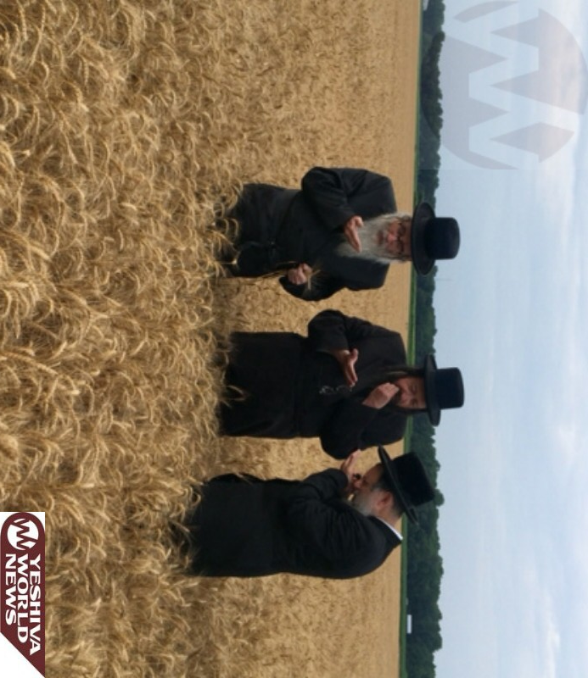

Photo Essay: Rabbonim of Debretzin, Brezna and Raved Karlesburg Inspecting Cut Wheat for Matzos in Maryland (Photos By JDN)
(Tuesday, June 23rd, 2015 03:15 PM)

Reprinted from the June 23, 2015 website of Yeshiva World News.
Story #959

Rebbetzin vs. Rabbi in Paris
By Shneur-Zalman Chanin
From the desk of Yerachmiel Tilles
editor@ascentofsafed.com

In 5717 (1957), after my sisters went to the United States and married and my father began supporting himself and earned a bit, we were able to leave the "hotel" and move to our own apartment. It was a five star apartment relative to the times. We had our own bathroom and even had hot water from the faucet. My father rented it from the chasidic rav, Rabbi Shneur-Zalman Schneersohn, who lived in the same house.
I have very pleasant memories of this period of time. I remember the spiritual wealth of those days. I remember some of the stories that R' Zalman Schneersohn told me and the chasidic melodies that he taught me when I came home. I was the only child there at that time, and he loved having me around. With my father's encouragement, I observed and learned from his ways.
Rav Schneersohn was a Jew of self-sacrifice. The other person was more important to him than himself and he fully complied with the Chassidic aphorism, "mine is yours" [and, of course, "yours is yours" - see Pirkei Avot ch.5 --yt]
He himself was destitute, but whoever asked him for help, got it. To all appearances he conducted himself expansively and on Shabbat he had many guests at his table. His apartment was considered an exclusive one and he had a very valuable library which gave people the feeling that they were in the home of a wealthy man.
He gave lessons in heavily-accented French to scientists, doctors and students, and knew people in high positions in all fields. However, despite his good connections, he had no money. When someone asked him for a loan and he did not have the money, he would borrow it from others in order to lend it.
It was in the days leading up to Pesach. Yeshiva had ended and I was home. Late at night, about ten or eleven o'clock, I heard R' Zalman Schneersohn call me, "Zalminka, where are you?"
I left our apartment and went to his magnificent office. Right away he said to me, "My child, please ask your father to come here."
I went to call my father. My father treated the Rav with great respect, both because he was a rav but mainly because he was from the Schneersohn family. He went to his office immediately. My father wasn't surprised by the request and the lateness of the hour. He thought R. Schneersohn wanted to borrow money for Pesach expenses, but I sensed that, this time, the request was different.
I remained in our apartment but, as any normal child, I was curious to know why the rav had called for my father at this late hour. After a few minutes I could not restrain myself and went on tiptoes from our apartment toward the Schneersohn apartment. I lay on the floor with my ear near the crack at the threshold.
My mother realized I had left the apartment and figured out where I had gone. She waited a few minutes and when I did not return she went to look for me and caught me snooping. She took me right back to bed, though not before "giving it" to me. My father remained in the office a long time and by the time he came back I was already asleep.
Although I was very curious about why R. Schneersohn had called my father, it did not occur to me to ask because I was terrified that my mother had told my father about my mischief. If I mentioned one word about that night, I would "get it" again. So I kept quiet. I was ten years old at the time and, typical of children, I forgot about the matter.

* * *
Quite a few years later, when we were living in New York, and R' Schneersohn had also moved to New York, my father would visit him often. I nearly always went along with him. One time, on our way back from one of those visits, while extolling the rav, my father told me what happened that night in Paris, in R' Schneersohn's office, behind the closed door.
My father had entered the office and found not only R. Schneersohn but also his wife, Rebbetzin Sarah. She began by saying, "Reb Chaikel, I want to take my husband to a din Torah (rabbinical court), and I want to ask you to be the judge for us and declare who is right."
My father tried getting out of it by saying he wasn't a rav, and certainly not an authority in Torah law, so how should he know how to rule? But the rebbetzin said, "I know you will rule better than any other rabbinical judge or rabbi. Both of us, my husband and I, rely on you and commit to doing as you say."
Having no choice, my father agreed. The Schneersohns made a binding exchange as is customary, and the rebbetzin--the plaintiff--began:
"It is a few days before Pesach and we have nothing for the festival--no matza, no wine, no meat, no fish. We don't even have pieces of bread for the B'dikat (Search for) Chametz. If I had ten pieces of bread, I would sit down right now and eat them with a cup of tea!
"Today I asked my husband for money for the holiday and he told me that he had nothing. I began to shout: 'Gevald! With my own eyes I saw, a few days ago, someone giving you an envelope full of dollars. What did you do with the money?'
"R' Chaikel, do you know what he told me? He calmly said, 'I gave the money as tzedaka, to those who need money for Pesach.'
"'What about us? Aren't we needy?' I asked. 'You want to give tzedaka? Fine, but leave a little bit for the household expenses for the upcoming Yom Tov!'"
My father heard her out and thought she was right, but he had to listen to the other side. How would the Rav justify himself? What could he say?
R' Schneersohn began to speak:
"There is a wealthy Jew by the name of Chaim who needed to arrange a heter Meia rabbanim (a clause in Jewish Law to enable a man to marry a second wife despite the thousand-year-old prohibition of Rabbeinu Gershom, in the instance where the first wife has gone mad and cannot accept a gett (bill of divorce). According to Jewish Law, it is necessary for at least one hundred rabbis to sign their consent in order to rescind the enactment) and he came to me for my help.
"After exchanging letters with a hundred rabbis, which took tremendous effort because of the slowness of the mail, until they wrote a letter and until they sent it, and until it reached its destination and until a response was received and the process was started over with another rabbi, a lot of time went by. On Rosh Chodesh Nissan [two weeks before Seder night], I finally arranged thegett. Mr. Chaim, was very appreciative of the work that I put into this and he gave me $5000 in appreciation of my efforts, in addition to my expenses.
"While the dollars were still warming my heart and my pocket, a Lubavitcher chasid came to me whose name I cannot disclose, and he told me that he has a large family with no bread to eat and no clothes to wear, and there is no money for for the festival. He told me he makes great efforts so that people will not know of his situation, so people assume he still has income. But now, before Pesach, he had no choice but to ask for help.
He burst into tears and asked me to have pity on him and help get him on his feet before it was too late.
"So Reb Chaikel, what could I do? Tell me what you would have done in my place? I thought, since becoming a rav, such a sum has never come into my possession. Was it not for a situation like this that I received it? Wasn't this a sign from Above showing me clearly that I had to get this man on his feet?
"I took out the money and immediately, before I could change my mind, I gave him all the money along with the envelope. It did not occur to me to take any of the money for myself.
"If you will ask, how will we manage for Pesach? Hashem will help. In the worst case, I assume that when Chaikel downstairs will loudly say kol dichfin ['All that are hungry let them enter and eat'-from the Hagaddah for Passover night], we will join him for the Seder and he surely won't chase us out."
My father told me that when he heard this story, he was struck silent. On the one hand, my father admired the rav's action but, on the other hand, the rebbetzin was right.
After some thought, he decided as follows:
"I, Chaikel, agree to give the rebbetzin the money she needs for the Yom Tov expenses, so that will satisfy her. However, I am giving it on condition that I am a partner in the mitzvah the rav fulfilled. I ask that the rav split his mitzva of 'azov taazov imo' ("Help your fellow-Jew in need") and Maos Chittim ('Wheat money'-i.e. money for matzah and other Passover needs) with me."
R' Schneersohn and my father made another binding exchange to ratify the new deal, and all parties were satisfied: the rebbetzin, because she had what she needed for Pesach; the rav, because he fulfilled the mitzvah and without any grievances on the part of his wife; and my father, because he got a share of this lofty good deed.
When my father told me the story, my admiration for my father went up sevenfold for his cleverness and the creative solution he proposed.

Source: Excerpted and adapted by Yerachmiel Tilles from Beis Moshiach #923 (English). Photo Credit: Hadassa Carlebach (posted on //kevarim.com)
Biographical note: Rabbi Shneur-Zalman Schneersohn (1898 - Wed. July 2, 1980 - Tammuz 18 5740) was a second cousin of the 7th Lubavitcher Rebbe, having a close relationship with him in Paris when they both lived there after 1936, even hosting the Rebbe's mother in his house for three months. He held the post of Chief Rabbi of the Association of Orthodox Jewry of France, and was well-known and highly respected for his work in saving more than one hundred children after the German occupation of Vichy France. In 1950, when the 6th Rebbe passed away, a small percentage of the chasidim considered him a fitting successor. Eventually settling in Brooklyn, he founded and headed for many years the Shevet Yehuda Institute of Technology, which offered a training program in computer science for yeshiva students, one of the first such programs ever. He is buried directly behind the Lubavitcher Rebbes' ohel, alongside the Tomashpol Rebbe, in the Old Montefiore Cemetery in Queens.
Connections: Seasonal-Just before Passover

Reprinted from the Parshas Metzora 5776 email of KabbalaOnline.org, a project of Ascent of Safed. www.ascentofsafed.com

A Tale of Two Matzahs
Why Shemurah Matzah?
By Avrohom Altein

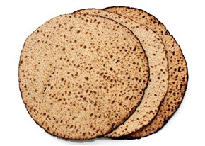
When Moses instructed the Jews to prepare matzah for thePassover Eve feast (scheduled for the night before their anticipated departure from Egypt), he enjoined them to "guard the matzahs" (Exodus 12:17). This verse is the basis of an interesting law. It is not enough to eat matzah on theSeder night; it is also a mitzvah to guard the matzah's dough as it is being prepared for baking, so that it does not rise.
Jewish law rules that there are two very different kinds of matzah.
One is the matzah that we eat throughout most of Passover. That matzah is considered "optional." We don't have to eat matzah; we could eat other foods that are not chametz (leavened) such as dairy, fish, meat, fruits and vegetables. As long as we do not eat chametz, we are in keeping with the rules of the holiday. If however we choose to eat bread, it would have to be of the matzah variety.
It isn't only the result that counts; it is also the effort we put into itThe situation is very different during the first two Seder nights of Passover. On those two nights it is mandatory to eat matzah, so that we recall the unleavened bread eaten by our ancestors as they left Egypt. The matzah of the Seder is called matzotmitzvah ("obligatory matzah") and there are special rules dictating how it should be baked.
An example of this concept would be the rules of a kosher mezuzah. The mitzvah of mezuzah begins even before we attach it to our doorpost; it starts with the way the mezuzah is written, with a skilled scribe (called a sofer) writing the words of the Shema on parchment. The scribe must be a Jewish adult, who himself is obligated in the mitzvah of mezuzah. A computer generated printout might be neat and precise, but it would not constitute a kosher mezuzah, because it is incapable of doing a "Jewish" mitzvah.
In very much the same way, the baking of the Seder matzah is the beginning of the mitzvah. Mixing the dough, rolling and shaping the matzah and putting the dough into the oven to bake—are all activities that must be performed by adult Jews. This is why machine-made matzah is not the best choice for the Seder. Hand-baked matzah is becoming more and more popular and many people eat them for the entire Passover. Certainly, the hand-baked matzah are the optimum choice for the Seder nights.
It is easy to recognize a hand-baked matzah, because they are round in contrast to the square-shaped machine-made variety. Interestingly, the Torah describes the matzah that the Jews ate when they left Egypt as "ugot," a Hebrew word that also means round-shaped.
There is an important lesson that we can learn from matzah. It isn't only the result that counts; it is also the effort we put into it. In today's world of automation, we sometimes forget the beauty and value of personal involvement. A mitzvah requires human effort (and there are few mitzvot that demand as much effort as the preparations for Passover...).
A machine can produce matzah that is neat and tasty, but it is human effort and hard work that makes the matzah a true mitzvah. Only hard effort can yield true value.

Reprinted from the current website of Chabad.Org

How to Feed a Hamster
And Other Pets on Pesach

Why: I need to ask you a question about my hamster. I do not know what I am going to do with her over Pesach, as I have asked my Rav and he has said that I should give her away to a non-Jewish person that I know, because the food is not acceptable on Pesach.
What should I do? I don’t want to give her away for Pesach, so could I feed her only vegetables and sunflower seeds (her favorite) and throw away the other food?
Even if I did give her away could I go over to the people that would be keeping her and play with my hamster? Please will you tell me the answer, as I am really desperate to know!

Because: A person is not only prohibited from eating chametz (unleavened bread) on Passover, but also from owning it or deriving any benefit from it. Thus, one may not own pet food that contains chametz or feed one’s pet with it during Passover. One may not even allow one’s pet to eat chametz that is given to it by a non-Jew.[1]


Pet Hamster
However, a person is permitted to sell his pet to a non-Jew for the duration of Passover. The animal should be housed in the home of the non-Jew.[2]
Jews of Ashkenazi extraction have a strict custom not to eat kitniyos – various legumes – on Passover. However, it is fully permitted to own such foods and to feed them to one’s animals. As long as they are stored away from any human food, kitniyos often make good pet food for Passover.
Many pet-owners are confused as to what to feed their pets on Passover, so we shall provide some practical guidance as to which foods are appropriate. Any change of diet should be done gradually, mixing in the Passover diet with the regular food several days before Passover. It is generally not advisable to give matzah to any animals, not even fish.
Dog and cat foods often contain chametz. However, several brands of food that are certified as being kosher for Passover are widely available. Note that the kashrus organizations that publish lists of products which are suitable for Passover often include a list of commercially available pet foods which are suitable. It is not necessary to buy a new food bowl for Passover, but the bowl should be thoroughly cleaned.
Commercial food mixtures for small animals such as rabbits, hamsters, and so on, contain problematic grains. It is best to feed them fresh vegetables, alfalfa, sunflower seeds, and dry corn. Commercial alfalfa pellets can also be purchased. Birdseed likewise usually contains problematic grains. It is best to feed them with sprays of millet. Birds of the parrot family should be given sunflower seeds, as well as fruits and vegetables.
Most fish-food contains chametz. A simple solution is freeze-dried brineshrimp, bloodworms or tubifex worms, which are available at all pet stores. If one is going on vacation, note that vacation “blocks” for feeding fish usually contain chametz. However, a healthy aquarium, with a mixture of fish and plants, can sustain itself for the duration of Passover without any food at all.
I would add that there is one animal that absolutely should be fed matzah: pet rats. They love it! And since they are generally happy with people food, there is no need to feed them anything different from what you eat; they are the only pet that, to my knowledge, can safely eat chocolate! [1] Shulchan Aruch, Orach Chaim 448:7. [2] Mishnah Berurah 448:33 and Aruch Hashulchan 448:12-13.

How Coca-Cola Prompted The Advent Of Passover-Friendly Food Companies
By Alina Dain Sharon

In the 1930s, Rabbi Tobias Geffen of Atlanta began to investigate the hidden ingredients inside mass-produced foods and to evaluate whether those ingredients conflict with kosher laws. He then set a precedent by getting The Coca-Cola Company to make a kosher-for-Passover version of its soft drink, convincing the company to substitute the grain alcohol used in the processing of its drink to alcohol derived from molasses.
Geffen’s achievement was a response to the fact that in the 1920s, “Coke became an incredibly popular beverage in America,” and “Jews adopted a custom of making it available to children during the Passover seder in lieu of wine,” historian Roger Horowitz—whose book, “Kosher USA: How Coke Became Kosher and Other Tales of Modern Food,” will be published by Columbia University Press this April—told JNS.org.

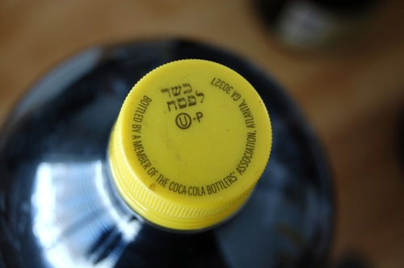

This step by Coca-Cola stood out at a time when few mainstream food manufacturers were making kosher-for-Passover products.
“Coke was an enormous consumer product in the 1930s, and jealously guarded its formula,” Horowitz said. Much of the company’s decision, he explained, rested on its confidence in Geffen that he would not reveal the drink’s secret ingredients, and the episode was “an enormous asset in persuading other conventional food firms to secure kosher certification.”
Geffen personally issued a kosher-for-Passover certification on Coke, eventually passing the baton to another rabbi. Meanwhile, the founder of the Orthodox Union (OU) and its kosher-certification labeling,
Abraham Goldstein, was another figure dedicated to the science of figuring out what’s inside foods and whether those ingredients are acceptable for Passover as well as for kosher-observant consumption year-round. He was particularly interested in ice cream, surveying its manufacturers to determine what they were putting inside their products and ultimately deciding that Breyers ice cream, for instance, is acceptable to eat during Passover.
But Goldstein was simply reviewing foods as they existed at the time. The fact that Coca-Cola chose to make a distinct version of its drink for Passover, therefore, was a big exception.
Rabbi Moshe Elefant, Chief Operating Officer of the OU’s kosher-certifying arm, told JNS.org that subsequently, the OU began to certify Coke for Passover around 1989-1990, after the company removed high fructose corn syrup from its Passover drink and replaced it with sugar. These bottles are known today for their distinct yellow caps.
When the OU certifies a product as generally kosher, it is typically sufficient for rabbinical supervisors to make occasional visits to a company to make sure that the product is being produced in accordance with kosher standards. When it comes to Passover, however, making a product that is kosher for the holiday requires full-time rabbinical supervision. One other food that illustrates this situation is quinoa, a type of grain that was only in recent years certified as both kosher and kosher for Passover by the OU.
“One of the staples of the kosher diet now is sushi. But there’s a problem with sushi on Passover because sushi is made with rice, and Jews of Ashkenazi descent don’t eat rice on Passover. How are you going to survive eight to nine days without sushi? You make it with quinoa,” Elefant said.
After many public requests for the OU to certify quinoa, rabbis needed to make their decision based on ancient texts and rules that were written in an era when quinoa did not exist.
“After much deliberation and discussion, we determined that quinoa is not part of that legume family. Then we sent a rabbi to the mountains of Peru, where quinoa grows and is packaged,” where he needed to see if “the quinoa is packaged or processed in the same machinery or equipment as non-kosher for Passover products, [which] would for lack of a better word contaminate the quinoa,” Elefant explained.
As a result—and similarly to how kosher-for-Passover Coke is produced—about once a year, producers of kosher-for-Passover quinoa make a certain amount of quinoa specifically for Passover. It is labeled “OUP,” with full rabbinical supervision of the production process. Then the rabbis go home, and come back later for the next production round.
Today, many food ingredients, as well as the final food product, are often made far away from the grocery shelves, particularly in the Far East, Elefant said. Therefore, the OU has become a highly global operation, with a presence in 80 countries. In addition, “the equipment used to manufacture food is all obviously new equipment that didn’t exist in the time of the Talmud,” he said.
In the current era of mass food production, the OU has needed to find out how to make production equipment kosher without the guidance of original source material with instructions on the issue.
Contemporary rabbis need to be “extremely knowledgeable in understanding the machinery that manufactures food,” and in knowing how to conduct the koshering process without breaking “a piece of equipment that costs millions of dollars,” Elefant said.
One issue that comes up with regard to Passover and food, according to Roger Horowitz, involves oils that may be used during the holiday. For instance, corn oil cannot be used, so rabbis must figure out how to control the oil while it is being shipped in trucks acrosslong distances in order to make sure the oil is not contaminated. All tankers need to be washed and sealed by rabbis before they can be reloaded, and any holding tanks must also be monitored by rabbis. Then, inside the factories, sophisticated control systems are also in place.
“You have to embed kosher requirements into the very food system, and what’s remarkable is how successful Orthodox Jews have been in embedding those requirements in our industrial food system,” Horowitz said.
Elefant cited another example of a product the OU has certified for Passover—canned tuna. “Over the years, we have made [specialized Passover] runs of tuna for Chicken of the Sea, Bumblebee, etc.,” he said.
“The tuna fish itself as a fish is inherently kosher for Passover. But all the other ingredients to make the tuna, [like] the vegetable broth that they sometimes put into the tuna…are not necessarily kosher for Passover,” added Elefant.
In yet another illustration, coffee doesn’t always require an OUP label to be considered as kosher for Passover. The OU also recommends one-ingredient foods that are considered kosher for Passover without requiring the foods to be labeled with an OUP. Decaffeinated coffee, however, can only be consumed on Passover if the decaffeination process does not involve an alcohol made out of grains or corn. Brands that the OU deems appropriate for Passover include Nescafe’s Taster’s Choice and Folgers.
“We had to review the entire decaffeination process to make sure there’s no issue,” Elefant said, noting that in these cases, the products were deemed appropriate for the Jewish holiday as they are. Yet in the case of Bosco chocolate syrup, which has also been labeled OUP, a separate version of the syrup needed to be made for Passover.
Statistics compiled by Lubicom Marketing Consulting (an agency working with kosher food producers) for last year’s Kosherfest trade show revealed the production of 600 new products for Passover, and that 40 percent of annual kosher food sales came during the roughly month-long period including and surrounding Passover.
Passover is the “most widely observed holiday on the Jewish calendar,” said Lubicom President Menachem Lubinsky, with an estimated 70 percent of all U.S. Jews attending at least one Passover seder.
Lubinsky added that making special Passover runs of products does not stop at food.
Aluminum foil companies producing kosher-for-Passover foil “have to use cleaning agents that are [suitable] for Passover. They do a special run and they have an OUP on them. The amount of those products that is consumed for Passover is enormous…[and] it’s good business [for the company to produce them].”
On the marketing side of the issue, Lubinsky sees a growth in the advertising of kosher-for-Passover products.
“You see a lot of supermarket ads that highlight Passover specials. There are also a lot online apps with Passover products. I see technology being used in a big way,” he said.
When a mainstream, non-Jewish company approaches Lubicom with an interest in marketing a special kosher-for-Passover version of its product, Lubinsky first determines if the product is unique, and if it is, he suggests that the company “be very user-friendly in teaching consumers how to use the product” through recipes, meal ideas, and tie-ins with other products that are also kosher for Passover.
As for Coca-Cola, when it had removed high fructose corn syrup from its ingredients in 1990, it did so in response to Passover consumers’ demand. But in more recent years, Elefant noted, consumers “are actually trying to stay away from high fructose corn syrup” for health reasons, prompting a growing number of food producers to remove the substance from many products and use natural sugars or fruit sugars as substitutes. This makes such products easier to certify as kosher for Passover.
In the end, Elefant said, “it always boils down to dollars and cents.”

Reprinted from the March 28, 2016 edition of Jewish Business News.
Why Does Shmura Matza for Passover Cost More Than Filet Mignon?
By Uriel Heilman
It might be burnt or taste like the box it came in, Jews from Brooklyn to Bnei Brak line up to buy it by the box-load.

JTA – It costs more per pound than filet mignon. It might be burnt or taste like cardboard. It’s so delicate it often breaks in the box, rendering it unfit for Passover ritual use.
Yet every year, Jews from Brooklyn to Bnei Brak line up to fork over their hard-earned money to buy boxes and boxes of the stuff.
This isn’t your regular box of Streit’s matza. We’re talking, of course, about handmade shmura matza: the artisanal, disc-shaped matzot considered extra special because the ingredients are “guarded” against leavening, or chametz, not just from the time the wheat is ground into flour, but from before the wheat is even harvested. “Shmura” is Hebrew for guarded.
The extra level of scrutiny — and the labor-intensive process required to make handcrafted matza — is largely what accounts for its high price: anywhere from $20 to $60 for a single pound.
“The amount of hours of labor going into this between me and my staff is incomparable,” said Yisroel Bass, who runs a farm in Goshen, New York, that produces organically grown shmura matza ($34 per pound for regular shmura, $37 for spelt).
“Renting out a bakery costs a lot of money – the space and the staff. Equipment breaks every year. Every farm has its expenses, and organic farms end up having more overhead. We can’t buy the synthetic fertilizer; we have manure,” Bass told JTA. “And G-d forbid I have a bad year and the rabbi comes and says the wheat is no good, I just spent a whole lot of time and money on a product nobody wants. The cost has to reflect that.”
Despite its price — and, some say, its taste — there’s a thriving market for handmade shmura matza (there’s also machine-made shmura, which is cheaper and usually square but more strictly scrutinized than regular matza). Many observant Jews won’t use anything other than handmade shmura matza on their seder table. Some won’t eat non-shmura anytime during Passover. The same Jews who light expensive olive oil menorahs on Hanukkah rather than wax candles or buy premium etrogs for Sukkot will lay out extra cash before Passover to buy handmade shmura matza. (The practice of going above and beyond is known as “hiddur mitzva,” beautifying the commandment.)

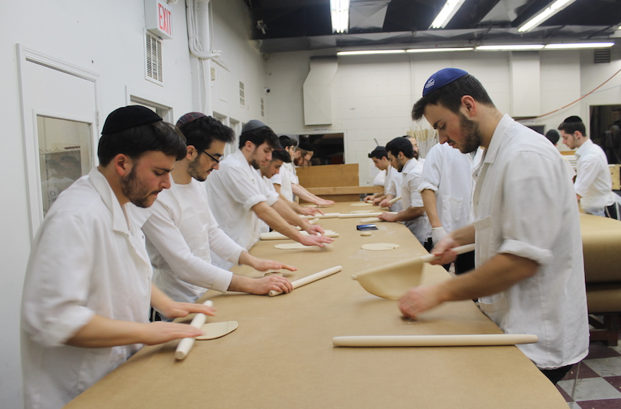
Matza dough is rolled into thin, round discs before it is perforated and baked. Every 15 minutes at the Satmar Bakery in Brooklyn, the work ceases while all surfaces are scoured or replaced.Uriel Heilman / JTA Photo Archive
“For the consumer, it is an opportunity to purchase the only sacred food that we have today in our faith,” said Rabbi Shmuel Herzfeld of Ohev Sholom synagogue in Washington, D.C. “It is a bargain. Buy less brisket and more shmura matza.”
Mitchell Weitzman, a lawyer from Baltimore, says shmura matza has sentimental value.
“There is just a sense of authenticity about having shmura matza on the table,” Weitzman said. “It’s a feeling more than anything else — certainly more than serving up Passover-style Fruit Loops the next morning.”
Why does Shmura Matza cost up to $60 per box? Here's a little insight to what makes this matza the most sought for.
Others say they like the taste and eat it year round, stocking up right after Passover when the price drops dramatically owing to reduced demand.
“I keep a box of shmura matza in the trunk of my car,” said Tali Aronsky, a public relations doyenne who lives in Israel. “Keeps crispy in all weather and great in a pinch.”
Religious Jews consider shmura matza baked after midday on the day before Passover — known as “matzot mizva” — as especially meritorious to eat, and the matzah is priced accordingly. At the Satmar Bakery in the Williamsburg section of Brooklyn, a pound of the Passover eve-baked stuff retails for $60. The line of customers at the Rutledge Street store usually snakes around the block.
The Satmar Bakery employs a number of stringencies rare even in the world of shmura matza. It harvests its wheat in Arizona, where the dry climate helps guard against accidental leavening (moisture precipitates leavening).
Matza farmers in the Northeast typically harvest their wheat crop in May or June – around the Shavuot holiday (also called Hag Habikurim, which means Festival of the First Fruits). The wheat is plucked after the kernels start to harden but before they sprout new shoots. Kosher supervisors monitor the grain even as it’s growing to make sure the wheat isn’t sprouting.
From the time it is picked until being milled months later, the wheat must be guarded and stored in a climate-controlled environment. Too moist, it could become chametz. Too dry, it will fail to bake properly. At the Yiddish Farm in upstate New York, Bass says he uses fans and computer monitoring to bring the moisture level down to the desired 11-12 percent level.
After the wheat is milled into flour – also under close supervision – the baking process may begin.
Timing is everything. Once the flour is combined with water to make dough, bakers have just 18 minutes to turn it into matza. Pass that threshold and the matza, like Cinderella at midnight, turns to chametz. At the Satmar Bakery in Williamsburg, the clock is set for a 15-minute countdown, just to be safe.
Bakers use water – drawn from a well, according to tradition, after sunset but before nightfall – and mix it with the flour to make dough. The dough is portioned, rolled into flat circles, perforated with tiny holes, draped on poles and thrust into a 1,300-degree, coal-and-wood-fired oven for about 20 seconds. After the matza cools, it is inspected for quality (burnt and broken pieces are discarded or sold at a discount) and boxed, seven to a pound.

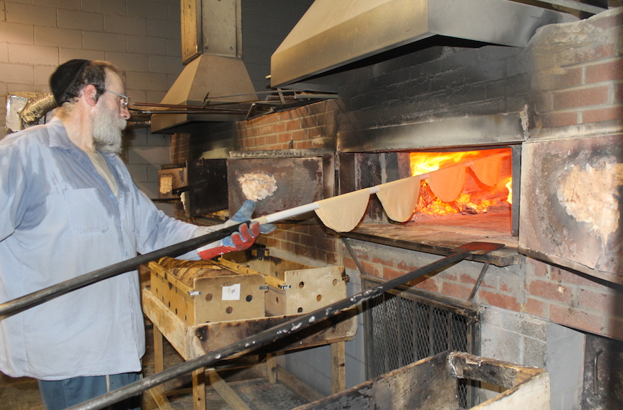
It takes about 20 seconds in a 1,300-degree, coal-and-wood-fired oven to bake

Between every 15-minute baking cycle, every surface that comes into contact with the dough must be scoured or replaced. If a stray bit of dough from the previous cycle remains, the older-than-18-minute crumb would be chametz and taint the dough used in the following cycle. That means hands must be washed and inspected, wooden rollers are discarded and replaced, and work surfaces are covered with fresh paper. All the workers who handle the dough or matza are supposed to be religiously observant.
“We make a little more than 1,000 pounds a day,” said manager Burech Yida Spitzer. “We vacuum-pack all the matzot. It stays the same fresh from October till Pesach.”
Not all handmade shmura matza is considered equal. There’s regular, whole wheat and spelt. There’s shmura baked by pious young women, called Beis Rachel matza — prized because the bakers are considered more reliably religious than ordinary matza workers for hire. There’s matza baked according to varying scholarly interpretations. And, of course, there’s broken matzot, which may be consumed during the holiday but are unfit for ritual use – for example, as one of the three official seder matzot or as one of the pair of matzot used at the beginning of all festival and Shabbat meals – because they’re not whole. Each variation is priced differently.
“We have 15 different kinds of matza,” said Eli Hershkowitz, who runs the Satmar Bakery. “It’s all very crispy and breakable. Most people buy it right at the bakery, but we also have a delivery service and take orders by phone and fax. I ship only at your own risk. If it’s going to California or Florida, it’s not going to make it intact.”
Hershkowitz spends part of the spring scouting wheat in Arizona and part of the summer dealing with etrogs in Italy and Morocco.
At these kinds of prices, a growing number of operators appear to be getting into the shmura matza business. Discount supermarket chains in Israel now sell relatively cheap shmura matza, and some American consumers say they’ve found handmade shmura matza at their local Costco for as little as $13 a pound.
Brooklyn resident Ber Braver says that’s not necessarily a good thing.
“Money is nothing, spirituality is everything,” Braver wrote on Facebook in response to a query from a JTA reporter. “What do you want — we should ship matzot also from China like Apple’s iPhones? No. We have to support our rabbis who work very hard producing those matzot with fervent yiras Shamayim” – fear of G-d. “They are holy and serve G-d with utmost sacrifice.”

Reprinted from the Jewish Telegraph Agency (JTA) release of April 3, 2016.
A Tefillah Before Pesach Cleaning and Preparations
By Orit Esther Reiter

I am prepared to perform the mitzvah of cleaning for Pesach; internally and externally, to clean away my fears, anger, sadness, worry, transgressions and faults. May it be Your will that all of my work should find favor in Your eyes and give nachat ruach to Hashem Yitborach.
Please Hashem help me serve You in happiness, to burn away any distractions coming from the yetzer hara such as tension, anger, frustration and sadness that disconnect me from You. I pray and hope that through my cleaning here below of my home and possessions I shall prepare myself emotionally and spiritually for the upcoming Chag Pesach.
I therefore ask that I go about my Pesach preparations with emuna shleimah and trust that whatever I am able to do is exactly what You want me to complete no more and no less. May I accept it all with love and inner calmness. I wish to clean my outer surroundings as well as my inner core of all chometz; from arrogance,anger and false sense of control. May I rectify all of the negativity that surfaces throughout my preparations and arrive to a place of wholeness
May I live by the passuk, Shiviti Hashem lnegdi tamid (Seeing Hashem in front of me always) and know that everything that I see is from YOU and none other. I want to fulfill only Your will Hashem and react out of emuna shleimah and simcha only. I pray to identify with my inner core of greatness, my G-dly spark, that is where my infinite power lies, my point of connection to You. I can overcome all negative inclinations by remembering that Your love for me is eternal and You desire only my ultimate best.
Help me identify with my infinite value no matter how much I am able to do and complete. Help me recognize that true value comes from attaching myself toYou through every circumstance and challenge. I want to always attach myself to happiness, patience, unconditional love, a positive mindset and thinking, and emuna shleimah.
The purpose of these days of preparation and the entire Chag Pesach is to free myself from the bondage of the yetzer hara so that I may be free to serve You on a soul level. An Eved Hashem is free from bodily restraints, impulses and negative middot. That is who I truly am and who I wish to uncover through my Pesach cleaning and preparations.

Reprinted from the March 29, 2016 email of JFlatbushonline.com

Pesah-Baking Massot
On Ereb Pesah
By Rabbi Eli J. Mansour

The Shulhan Aruch (559) records a custom to bake the Massot for the Seder on Ereb Pesah after Hasot (Midday).The reason for baking in such a narrow timeframe is based on the analogy of Massa to the Korban Pesah. Just as the Pesah offering was brought after noon on Ereb Pesah, so too the Massot for the Misva of the Seder are also baked at that time.
The Tur (Rabbenu Yaakob Ben Asher, 1269-1343) and the Rosh (Rabbenu Asher Ben Yehiel, 1250-1327), record this as a mandatory practice. According to them, one does not fulfill the Misva of eating Massa with Massot baked at another time.
However, Maran formulates this practice as a custom, not as a requirement. In fact, the Mishna Berura (Rav Yisrael Meir Kagan of Radin, 1839-1933) and the Aruch Ha’shulhan (Rav Yechiel Michel Epstein of Nevarduk, 1829-1908) point out that most people do not observe this custom.
It is too “risky” to bake Massot after noon on Ereb Pesah, since there are opinions that even a “Mashehu”-minute amount of Hametz is forbidden. It is too difficult for most people to safeguard against even a particle of Hametz. Therefore, the majority of Jews get their Massa before Ereb Pesah. The Vilna Gaon, Hazon Ish and the Brisker Rav did not follow this practice. On the other hand, Hacham Ovadia and Hacham Ben Sion would make a point to use Massot baked on Ereb Pesah for the Seder.
According to the Hida (Rav Haim Yosef David Azulai, 1724-1807) and Rav Haim Palachi (Turkey, 1788-1869), those who do bake Massot on Ereb Pesach, follow the order of the service in the Bet Hamikdash.
They first pray Minha Gedola (Early Afternoon Service) corresponding to the “Tamid Shel Ben Ha’arbayim”-The daily afternoon offering-which was brought before the Korban Pesah. They then bake the Massot while reciting the Hallel, as was sung by the Leviim during the sacrifice.
SUMMARY: It is praiseworthy to use Massot baked on Ereb Pesah after Hasot for the Seder, if there is a reliable Hashgacha supervision.

Reprinted from the April 6, 2016 email of Rabbi Mansour’s Daily Halacha.

Elijah's Favorite Seder
By Rebecca Rubinstein

A great Rabbi finds out that Elijah liked best the simple Seder of a poor man who captured the meaning of Pesach in one heartfelt prayer.

Rabbi Levi Yitzhak of Berditchev, one of the great Hassidic teachers, looked forward to Seder night every year.
One year, after the Seder was over, Rabbi Levi Yitzhak went to sleep, content. He had conducted a great Seder with all his students round the table.
He fell into a deep sleep and dreamt a strange dream.
In the dream, the prophet Elijah is talking with the angels, giving them an account of the Seder he saw in Jewish homes. He describes the kids' excitement as their eyes are glued to the cup for Elijah to see if he came to visit them this year.
One of the angels asks, "But which was the most important Seder that you visited? Was it Rabbi Levi Yitzhak's?"
"Truth be told," Elijah answers, "Rabbi Levi Yitzhak's Seder was full of interesting discussions on the Haggadah, but it cannot be compared to the Seder of Chaim the water carrier."
At that Rabbi Levi Yitzhak woke up with a start and jumped out of bed. He had to speak to this water carrier named Chaim right away.
He shook awake one of his students who had fallen asleep at the table and sent him to seek out Chaim.
Eventually, the student found Chaim in a tumbledown hut at the edge of the town and brought him, dazed and barely awake, to Rabbi Levi Yitzhak's house.
Rabbi Levi Yitzhak welcomed the puzzled man, and offered him a chair opposite him. Then he asked, "Tell me, my good Chaim, what happened last night at your Seder?"
Ashamed, looking down at his shabby shoes, Chaim answered:
"What kind of a Seder could an ignorant, tired fellow like me have? Yesterday, the day before Passover was a very hard day. All the houses were being cleaned, and water was in great demand. I walked backwards and forwards all day, trying to supply everyone with enough water. I slaved away with not a moment's rest.
"At the end of the day, I arrived home, half dead from exhaustion. My wife Rachel was just lighting the candles for the festival and I asked her to let me rest a while, and I fell into a deep sleep. When I awoke it was nearly dawn.
"Of course, I quickly woke up Rachel. There was no time now to read the whole Haggadah, so we drank the four cups of wine, and ate the matzah and some maror, and with whatever time I had left, I pleaded with God: 'Almighty, please forgive a simple ignorant man. All I know is that you delivered us in the past from the cruel hands of the Egyptians -- you have led us out of slavery to freedom. And now we are all in exile again, and I ask you with all my heart to lead us again into freedom!"
Having finished his story of woe, the water carrier waited, sure that the great Rabbi Levi Yitzhak would reprimand him for not making a proper Seder.
But instead, Rabbi Levi Yitzchok put his hand on Chaim's shoulder and turned to his students and said, "It is extremely important to follow the order of the Seder, but now we know why this man's Seder was the most pleasing to Elijah the Prophet."
Judaism teaches that "Every individual has to see himself as though he himself was redeemed from Egypt." Telling over the story of going out of Egypt is not enough -- we have to connect with it ourselves.
Chaim, a simple ignorant Jew, in his one sentence Seder, found favor in G-d's eyes, because of the depth of his sincerity and his commitment to do the best that he knew. "What comes out of the heart, goes into the heart."
What did Chaim do at his Seder that made it more important than even Rabbi Yitzhak's Seder in the eyes of the Prophet Elijah?
What can we learn from this story?
Chaim asked from a really sincere and honest place for G-d to give him freedom and did the best that he could. He honestly felt a personal going out of Egypt.
Our intentions are very important when we do a mitzvah. Only God can know what is in our hearts.
Even the wisest of men can learn from a simple person. In Ethics of the Fathers, the Sages teach: "Who is a wise man? Someone who learns from every person."

Reprinted from the website of Aish.com

